Solent University

Software Design and Development

COM714

# Introduction

The Travel Management System (TMS) is built to oil the cogs of travel activities by reducing human efforts on the trip planning and management functions. In the present day fast-moving times, travel management has become a competent part for the organizations as well as for the people for ensuring effortless and problem free travel experiences. The objective of this report is to provide a brief summary about the use of TMS and reveal its most important features along with a explanation about the modern business travel practices.

The TMS is a fully fledged solution that allows to perform a number of functions such as trip creation, update, deletion, and management of both travellers and trip legs which contribute to the management of trip coordinator. By relying on technology, the TMS aims at streamlining and expediting, while increasing competence and ease, the processes that are involved in planning and execution of journeys. As a result, the entire system becomes more user-friendly.

# System Overview

## Purpose:

The travel management system is a web-based technology that is meant to bring together all the necessary details related to trip planning and execution of the trip in real-time. What it intends to do is to improve the ease of getting trips prepared, travellers' supervision, and seduced by the various trip legs and trip coordinators' management. This automation system eradicates the paperwork, illegible handwriting, and manual errors. The end result is general improvement efficiency of the travel management process.

## Scope:

The TMS covers all trip-related activities i.e. trip planning which includes but is not limited to; updating, creating or deleting trips, managing traveller profiles and details, organizing trip legs, and working with trip coordinators (the seat fillers) as well. In addition, it not only generates invoice for journeys but also it provides reporting and analytic tools that enable tracking trip performance, detailed financial statements, traveller overview and much more. The TMS is offered among the organizations and people who often undertake traveling duties and need inexpensive solutions to aid them in the management of their travel processes.

## Objectives:

Efficiency: The primal aim of the TMS is to make use of the automation and eliminate manual tasks, paperwork, along with errors, so that the efficiency of travel planning will be increased.

Accuracy: Through centralization of trip information and data of the traveller, being the core of the TMS guarantees accuracy in trip preparation, zeroing-in and coordination.

Convenience: Through the TMS, visitors will find a platform that is simple to use for travel route planning, organizing and tracking. It is done with a view to improve the general experience during trips.

Data Analysis: Through its reporting and analytics capabilities, the TMS gives users a chance to make decisions based on data. Thus they get to know the trips’ performance, financial summaries, and traveler statistics, which enables them to make data-driven decision-making.

Scalability: The main instruction of this different system is to meet the statistics as well as requirements of users of all types such a persons with personal trip or agencies with multiple trips. It fulfills scalability to be able to adapt to new needs and sufficient user sizes.

# System Architecture

The Travel Management System (TMS) implements a client-server architecture, which is split into two parts: the client-side providing a convenient interface interacting with users, and the server-side storing data, performing business logic and processing it.

## UML Diagrams:

### Class Diagram:

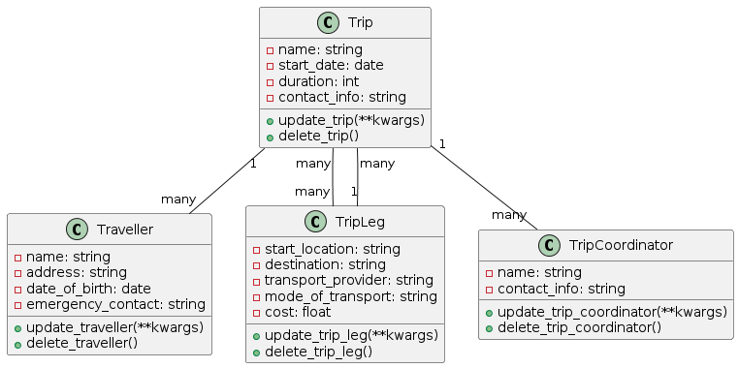

The Class diagram is a static structure diagram showing the classes, their attributes, methods, and their relationships, as well. This data model contains the following entities: Trip, Traveller, TripLeg, TripCoordinator, and TripManager with their attributes and methods as a part of them as well.

### Use Case Diagram:

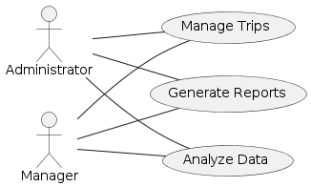

In Use Case Diagram, it is shown actors (users) and system what kind of relationship they build among themselves. It does this by illustrating all the functions that users can carry out, e.g., creating trips, managing travellers, updates a trip's status, making invoices, etc.

### Sequence Diagram:

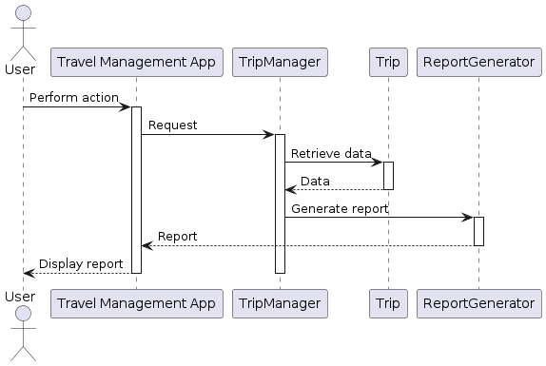

A Message Sequence Chart (MSC) is a representation of the message flow and a sequence of interactions between objects in a certain use case from top to bottom. The diagram presents the list of things to do in order, for example, to form trip or to update client information and so forth.

### Robustness Diagram:

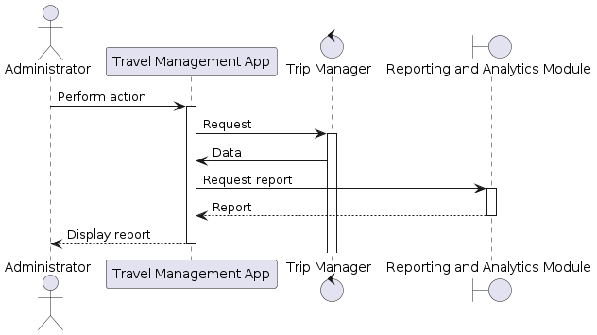

The Robustness Diagram evidently concentrates on the cases of the system's unwillingness to break down under various conditions and exceptions. This scenario shows how the system is well-equipped to deal with the errors, exceptions and other types of unexpected inputs and also makes sure the correct result is provided, thus making the system user friendly and appreciated.

# System Components

Travel Management System (TMS) is a system that comprises several key elements, each responsible for managing a variety of activities related to business travel.

## Trip Management:

Trip Management entails trip building within the system as well as modifications and deletions. This section provides a space to add fast travel details such as name of trip, start date, duration, and contact info. Travelers can create a new route, update the existing route information if any and also can delete the route whenever needed. The class of Trip Manager encompasses the responsibility of working with the trip management, including validation of input data and the ability to communicate with the database.

## Traveller Management:

Traveller Information Management is in charge of storing the information of “Travellers” into the system. Users can insert data like a traveller’s full name, residential info, date of birth and emergency contact in the given form. Mis acquisition of the traveller information is supervised by udatior component. The Traveler class embrace persons who are travelling and the Traveller Manager class aims at taking care of activities related to management of travelers such as addition, update and removal of travelers records.

## Trip Leg Management:

The management of Trip Leg comprises of determining a particular place to the starting point as well as to the ending point before analyzing the transport providers, modes of transport and the all associated expenses. Input boxes and a calendar help users enter and edit trip leg details, allowing them to plan and update every trip. The TripLeg type of class depicts the trip legs per se, while the Trip Leg Manager class oversees the operation of data related to trip leg management for instance adding updating and removal of trip leg records.

## Trip Coordinator Management:

In trip coordinator management, the key aspect is about effective managing of trip coordinators whose responsibilities are to organize and coordinate trips. Such details as coordinator name and contact information may be inputted as well as updated through the app. This component guarantees both successful communication and cooperation of differing parties, including trip coordinators other individuals responsible for trip planning and implementation. TripCoordinator class stands for trip coordinators and the Trip Coordinator Manager class handles the various operations needed to process trip coordinator requests, such as adding, updating and deleting new coordinator records.

# Implementation Details

The Travel Management System (TMS) is going to be programmed in Python with the Tkinter library for creating a GUI (Graphical User Interface). See details outlined below such as utilized technologies, code structure, and the most crucial features and functions.

## Technologies Used:

The platform uses a python programming language due to its simplicity, flexibility, and a broad choice of modules. Tkinter, a library that is built-in in python, is used in building the GUI which gives users who interact with the system a chance to use an interface that is intuitive and user friendly. Furthermore, the system applies OOP principles (object-oriented programming) to the modules and classes for the purpose of code abstraction and easily scaling.

## Code Structure:

Codebase is structured into several classes that are responsible for describing the system classes. Each entity like Trip, Traveller, TripLeg, TripCoordinator with managers, is encapsulated into their own classes to maintain modularity and ensure the maintainability of the system. The GUI components are coiled up using Tkinter viotlets, such as Labels, Entry fields, Buttons, and Listboxes, arranged within the grid layouts for the purpose of both visual clarity and interaction with the user.

## Key Features and Functions:

Trip Management: Users here will be able to get done with the creation, updation, and deletion of the trips. The trip name, start date, duration, and contact information should be provided in this application as essential details. These actions are run by the Trip Manager class with the purpose to create error-less and legit data.

Traveller Management: The system to access traveller information is developed for users where they can manage and provide details like name, address, date of birth, and also have contact of an emergency person. A set of methods for creating, updating and deleting passenger information is provided by the Traveller Manager class, ensuring the accuracy and up-to-date passenger records.

Trip Leg Management: There are various facility to adapt to the needs, specify of legs, number of segments, transport providers, mode of transportation, and estimated cost to be incurred. The Trip Leg Manager is the class that implements the save, update, and delete functionality, therefore, users can input and retrieve a large number of details about their trips.

Trip Coordinator Management: Structured hikes or trips lead by professionals who educated hikers about the these mountain regions can easily be organized by the system. "Users can feed and update coordinator details eg names and contacts details. The Trip Coordinator Manager class provides the oversees here which is the operations are largely facilitates the effective communication and coordination among trip stakeholders.

# Reporting and Analytics

The Reporting and Analysis module of the TMA is the most salient information portal for managers and administrators to understand what is important and what is not, enabling appropriate planning and decision-making. This section introduces the Trip Duration Report that, methodologically and visually, will show the travel duration grouping.

## Trip Duration Report:

The Trip Duration Report Will Add to the Comprehension of how long trips Particularly the trips that have been undertaken within the given time frame have been. It reveals the length of trips as one of their most basic parameters, this overview gives an administrator the possibility to see a whole picture and decide whether some trip needs to be varied or optimized. Through such a time frame analysis, authorities can determine how satisfactory and effective the improvement in time travel arrangements may have been and identify ways to simplify not only the itinerary plans but also allocation of resources as well.

## Methodology:

The strategy for compiling the Trip Duration Report requires collecting data on the trip start times and duration provided by the system from its database. The system captures these stats and uses the onset and ending dates to compute the trip duration. In the meantime, the trips are classified into the numbered time intervals, that is to say, an opening - for instance - day, week, or month or a shorter granularity if required. Lastly, the trip duration data is prepared for aggregation to make counter check and correlate the patterns, trends and damages.

# Data Visualization Techniques:

The reporting system relies on visualization techniques for telecommunication of Trip Duration report, like histograms, bar charts, and line graphs. By employing these methods, the partners can create a visual representation of trip duration and distribution which allow stakeholders to review and understand the trips easily. The bars in histogram provide a visual of frequency distribution over trip durations, in turn showing commonly used duration ranges. The bar chart is constructed to display the average duration of all trips belong to each category, such as trip types and destinations, so for comparisons among different categories, the stakeholders just need to easily figure out the duration of each trip. Lines graphs show peaks and valleys on travel time durations that can occur during the season or changes of travel behavior.

# Conclusion

Ultimately, the Travel Management System (TMS) provides a wide range of opportunities for their employees to plan and manage their business trips effectively as well as analyze the trips spent. The TMS introduces an easy-to-use and powerful tool that helps head immediately people and managers realize various benefits as they improve their travel operations, enhance traveler experiences, and optimize the utilization of their resources. In an integrated system, Reporting and Analytics section has the ability to offer reports that show exact trip duration; therefore, the operators can make more data-driven decisions, which will lead to further improvements of the system. Fundamental advantages of data visualization and modern technologies ensure that the TMS enables organizations to compete in a rapidly changing environment of the trips market.

# References

Saabith, A.S., Vinothraj, T. and Fareez, M., 2020. Popular python libraries and their application domains. International Journal of Advance Engineering and Research Development, 7(11).

Gruber, M., Lukasczyk, S., Kroiß, F. and Fraser, G., 2021, April. An empirical study of flaky tests in python. In 2021 14th IEEE Conference on Software Testing, Verification and Validation (ICST) (pp. 148-158). IEEE.

Kong, Q., Siauw, T. and Bayen, A., 2020. Python programming and numerical methods: A guide for engineers and scientists. Academic Press.

Matthes, E., 2023. Python crash course: A hands-on, project-based introduction to programming. no starch press.

Linge, S. and Langtangen, H.P., 2020. Programming for computations-Python: A gentle introduction to numerical simulations with Python 3.6 (p. 332). Springer Nature.

Harris, C.R., Millman, K.J., Van Der Walt, S.J., Gommers, R., Virtanen, P., Cournapeau, D., Wieser, E., Taylor, J., Berg, S., Smith, N.J. and Kern, R., 2020. Array programming with NumPy. Nature, 585(7825), pp.357-362.